AM000-Asia-Japan-Mirror-Edo-Dragon-Eight Crescents-55 mm

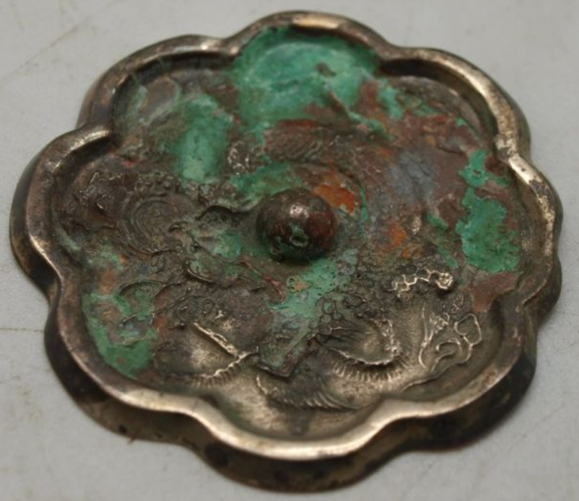

# Oriental Dragon - Silver Plated - 55mm

Stunning bronze Japanese mirror measuring 55mm in diameter.  This bronze mirror is silver plated, but has been heavily tarnished.  The back is decorated with primitive scenes of an oriental dragon.  It has a central boss which is pierced to allow a cord to be passed through for holding.  The other side is undecorated and would have originally been polished to create a reflective surface.